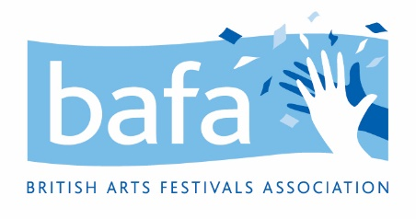

**British Arts Festivals Association (BAFA)**

**Volunteer Management Policy**

*2nd June 2021*

# Introduction and Scope

British Arts Festivals Association recognises the significant and valuable role that volunteers play in helping us to achieve our aims. We value the contribution made by volunteers and are committed to providing the support and recognition they need for personal development.

# Definition of the Relationship

1. A Volunteer is not an employee and will not have a contract of employment with BAFA.

2. Volunteering is defined as unpaid activities undertaken by individuals who freely offer their time and commitment to contribute to our work.

# Principles

This Volunteer Management Policy is underpinned by the following principles:

* British Arts Festivals Association will endeavour to ensure volunteers are properly integrated into its organisational structure and that they are kept abreast of organisational developments where appropriate and that necessary mechanisms are in place for them to contribute to our work.
* British Arts Festivals Association does not aim to introduce volunteers to replace paid staff.
* British Arts Festivals Association recognises that volunteers require satisfying work and personal development opportunities and will seek to help volunteers meet these needs.
* British Arts Festivals Association expects staff to work positively with volunteers.

# Recruitment and Selection

British Arts Festivals Association aims to ensure that we recruit volunteers who are suitable for the role they would like to do:

1. British Arts Festivals Association will provide volunteer role descriptions which outline duties and responsibilities.
2. Prior to appointment, volunteers are invited to engage in a two-way discussion of the proposed role including its requirements and expectations with a view to assessing mutual suitability.
3. Support, guidance and supervision are provided as appropriate.

# Equal Opportunities and Diversity

British Arts Festivals Association is committed to promoting equal opportunities. Volunteering opportunities are open to all regardless of age, race, disability, class, ethnic origin, gender, marital status, nationality, national origin, race, religion, sexual orientation, and pregnancy or maternity. We recognise the positive benefits a diverse volunteer pool can bring to the organisation and is committed to ensuring our recruitment and selection procedure reflects this.

# Induction and Training

All volunteers will receive a general orientation on the nature and purpose of the organisation as well as task specific training to ensure they can carry out their work on behalf of British Arts Festivals Association effectively and efficiently.

# Confidentiality

Volunteers are responsible for maintaining the confidentiality of all privileged information to which they are exposed. Failure to maintain confidentiality may result in termination of the volunteer’s relationship with the organisation.

# Support

All volunteers will have a named supervisor responsible for the management of their work, who is there to provide guidance and assistance. Those engaged in more sustained volunteering will have more formal supervision sessions at agreed intervals. These sessions shall be conducted via email, phone or face-to-face as appropriate and agreed.

# Volunteer Expenses

We are currently not in a position to be able to offer expenses for our volunteers.

# Health and Safety

All volunteers volunteering in at an event held by British Arts Festivals Association are to be given a Health and Safety induction.

# Concerns and Complaints

British Arts Festivals Association is committed to the welfare of our volunteers and we believe that any concerns brought to light can be dealt with between Volunteer and Manager. All volunteers have the opportunity to feedback to the Volunteer Manager through evaluation forms or meetings, depending on the volunteer role.

*To be reviewed on 2nd June 2022*