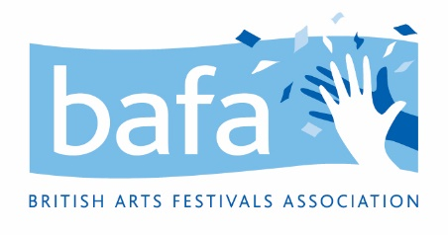

**British Arts Festivals Association (BAFA)**

**Safeguarding Vulnerable Beneficiaries Policy**

*2nd June 2021*

British Arts Festivals Association acknowledges the duty of care to safeguard and promote the welfare of vulnerable people and is committed to ensuring our safeguarding practice reflects statutory responsibilities, government guidance and complies with best practice.

British Arts Festivals Association on the whole is aimed at those working in the festivals sector and partners and agents associated with the sector, meaning that it is rare that the organisation would be coming into contact with children or vulnerable people. However, we do hold annual events in which young persons or vulnerable adults may be in attendance.

The policy recognises that the welfare and interests of children and at-risk adults are paramount in all circumstances. It aims to ensure that regardless of age, ability or disability, gender reassignment, race, religion or belief, sex or sexual orientation, socio-economic background, all people

* have a positive and enjoyable experience at events held by British Arts Festivals Association in a safe environment

As part of our safeguarding policy British Arts Festivals Association will

* promote and prioritise the safety and wellbeing of children and vulnerable adults
* ensure everyone understands their roles and responsibilities in respect of safeguarding and is provided with appropriate learning opportunities to recognise, identify and respond to signs of abuse, neglect and other safeguarding concerns relating to children and vulnerable adults
* ensure appropriate action is taken in the event of incidents/concerns of abuse and support provided to the individual/s who raise or disclose the concern
* ensure that confidential, detailed and accurate records of all safeguarding concerns are maintained and securely stored
* will follow the latest guidance relating to Safer Recruitment
* ensure robust safeguarding arrangements and procedures are in operation.

The policy and procedures will be widely promoted and are mandatory for everyone involved in British Arts Festivals Association. Failure to comply with the policy and procedures will be addressed without delay and may ultimately result in dismissal/exclusion from the organisation.

**DBS**

For the purposes of ensuring that British Arts Festivals Association are taking the necessary precautions should our events have attendees who are vulnerable adults or under 18 we will retain a list of BAFA trustees who have current DBS checks. These will be checked every 5 years.

**Monitoring**

The policy will be reviewed a year after development and then every three years, or in the following circumstances:

* changes in legislation and/or government guidance
* as a result of any other significant change or event.