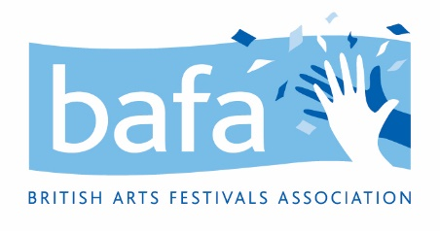

**British Arts Festivals Association (BAFA)**

**Disciplinary Procedure**

*2nd June 2021*

**Purpose and Scope**

The organisation’s aim is to encourage improvement in individual conduct or performance. This procedure sets out the action which will be taken when disciplinary rules are breached.

**Principles**This procedure is designed to deal consistently and efficiently with disciplinary issues. No disciplinary action will be taken until the matter has been fully investigated.

At every stage, employees, freelancers and contracted staff will be informed in writing of what is alleged and have the opportunity to state their case at a disciplinary meeting and be represented or accompanied, if they wish, by a trade union representative or a work colleague.

An employee has the right to appeal against any disciplinary penalty.

**Procedure  
  
Stage 1 – First Warning**If conduct or performance is unsatisfactory, the employee, freelancer or contracted team member will be given a written warning or performance note. Such warnings will be recorded, but disregarded after 3 months of satisfactory service. The individual will also be informed that a final written warning may be considered if there is no sustained satisfactory improvement or change. (Where the first offence is sufficiently serious, for example because it is having, or is likely to have, a serious harmful effect on the organisation, it may be justifiable to move directly to a final written warning.)

**Stage 2 – Final Written Warning**

If the offence is serious, or there is no improvement in standards, or if a further offence of a similar kind occurs, a final written warning will be given which will include the reason for the warning and a note that if no improvement results within 6 months, action at Stage 3 will be taken.

**Stage 3 – Dismissal or Action Short of Dismissal**

If the conduct or performance has failed to improve, the individual may suffer demotion, disciplinary transfer, loss of seniority or dismissal.

**Gross Misconduct**

If, after investigation, it is confirmed that the individual has committed an offence of the following nature (the list is not exhaustive), the normal consequence will be dismissal without notice or payment in lieu of notice:

* theft
* damage to property
* fraud
* incapacity for work due to being under the influence of alcohol or illegal drugs
* physical violence
* bullying and gross insubordination
* harassment

While the alleged gross misconduct is being investigated, the employee, freelancer or contracted staff member may be suspended, during which time he or she will be paid their normal pay rate. Any decision to dismiss will be taken by the employer only after full investigation.

**Appeals**

An employee, freelancer, or contracted staff member who wishes to appeal against any disciplinary decision must do so to the named person in the organisation within five working days. The employer will hear the appeal and decide the case impartially.