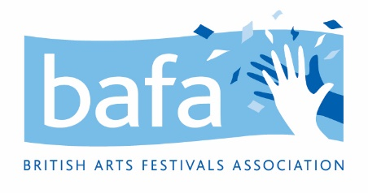

**British Arts Festivals Association (BAFA)**

**Conflict of Interest Policy**

*28th June 2021*

**Purpose**

The purpose of this policy is to protect the interests of British Arts Festivals Association. In the regular course of business, agents and employees of British Arts Festivals Association may have the opportunity to advance their own personal interests with or against the interests of British Arts Festivals Association. Acting in such a manner is unacceptable and any party who acts outside of British Arts Festivals Association best interest may be subject to disciplinary action.

**Definitions**

Employee: any person who is employed by British Arts Festivals Association in a part or full-time capacity.

Agent: trustee or other third-party that is in the position to act on behalf of British Arts Festivals Association.

Financial Interest: the interest that any individual may have in the monetary transactions of British Arts Festivals Association. In particular, any interest that could have a direct bearing on the financial gain or loss of said individual.

**Procedure**

1. **Duty to disclose**   
   Every employee or agent of British Arts Festivals Association is obligated to disclose any known or potential conflicts of interest as soon as they arise. Failure to do so could result in termination of employment.
2. **Investigating potential conflicts**  
   When a possible conflict of interest arises, the board of trustees will collect appropriate information and may question any concerned parties. If the board determines that a conflict exists, steps will be taken to address to conflict. If no conflict exists, the inquiry may be documented but no further action will be taken.
3. **Addressing conflicts of interest**When an actual conflict of interest is found, any transactions that may have been affected will be reviewed retroactively. Affected parties both within and outside of the business, including employees, and trustees will be notified. An investigation will also be conducted by the board to determine the extent of the conflict and the intentions of the parties involved.  
   If the conflict in question involves a member or members of the board of trustees, this member will not be involved in these deliberations.
4. **Disciplinary action**  
   As all conflicts of interest will be reviewed on a case-by-case basis, a review may result in disciplinary action. The board of trustees has full discretion to deem what disciplinary action is both fitting and necessary, including suspension and/or termination of employment.

British Arts Festivals Association will maintain a register of interests for trustees and will refer to the governing document and the [Charity guidance](https://www.gov.uk/government/publications/conflicts-of-interest-a-guide-for-charity-trustees-cc29) for the process relating to trustee conflict of interests and/or conflicts of loyalty.

______________________ ___________________________

Employee Name Date  
  
______________________  
Signature