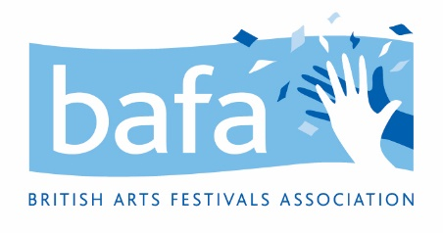

**British Arts Festivals Association (BAFA)**

**Complaints Handling Policy**

*28th June 2021*

**Purpose**

The purpose of this policy is to have a clear and concise way of responding to customer complaints (either members or event attendees).

**Procedure**

1. Outline British Arts Festivals Association registered address and/or email to send complaints
2. Reply to the customer complaint within 14 days.
3. If the complaint is not resolved within this time, British Arts Festivals Association will conduct a meeting with the complainant to discuss their concerns

British Arts Festivals Association will keep records of all communication regarding complaints.

*To be reviewed 28th June 2022*